Challenge Number 964

Played on date: January 23, 2016 Time: 1:00pm
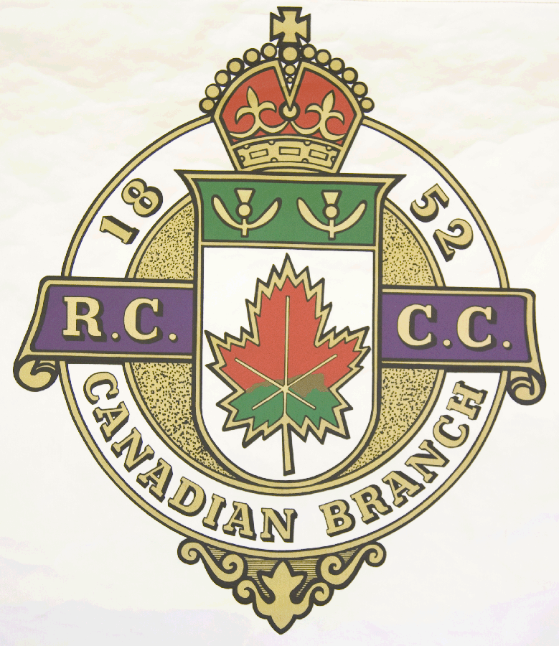
Hosting Club: _ Ormstown Curling Club_____
Host Club Address: _ 7 Chateauguay _____
Host Club City: _ Ormstown, Qc._____________

Host Club Telephone: (450) 829 – 2855

Host Contact Person: Fred Hutchings
Contact phone or email : f.hutchings@sympatico.ca

Hosting Club: Ormstown Challenging Club: Dalhousie Lake

Skip: Simon Rember Skip: John Wilson

Third: Jeff Rember Third: Andrew Lawton

Second: Taylor Lamb Second: Ken Wilson

Lead: Geoff Elliot Lead: Gerry Moore

Skip: Shawn Blair Skip: Dale Wilson

Third: Shane McRae Third: Don Chasse

Second: Tim Rember Second: Mike Cochrane

Lead: Mike Greig Lead: Kevin Debder

 | Skip | 1 | 2 | 3 | 4 | 5 | 6 | 7 | 8 | 9 | 10 | Score
Sheet 1 | S. Rember | 2 | 0 | 0 | 2 | 0 | 1 | 1 | 0 | 1 | 0 | 7
Sheet 1 | J. Wilson | 0 | 1 | 1 | 0 | 1 | 0 | 0 | 1 | 0 | 3 | 7
Sheet 2 | S. Blair | 0 | 2 | 0 | 2 | 0 | 3 | 1 | 0 | 1 | 0 | 9
Sheet 2 | D. Wilson | 1 | 0 | 1 | 0 | 1 | 0 | 0 | 3 | 0 | 1 | 7

Hosting club Score: 16 Challenging club score: 14

Note: Description of the game should follow on separate page as well as photos of the teams.

